Dropbox SSE Project
Authors
Donald Talkington - dst071000
Kevin Hulin - kjh061000
Camron Quitugua - cjq061000
Submitted Wednesday November 30, 2011

How To Use Program

Authenticating User

If no user is current authenticated, the following java window will pop up:

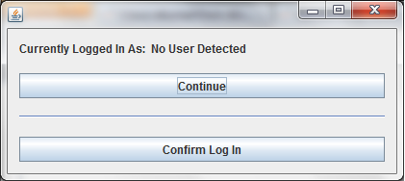
In addition to this window, the following page will pop up in your default web browser:

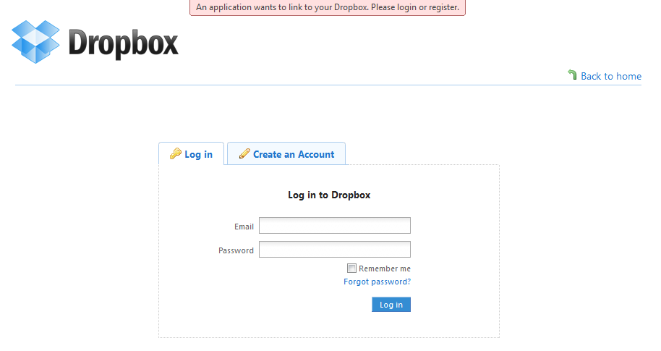
Log in to your dropbox account in the dropbox window and then click the "Confirm Log In" button in the java window. Note that the Current User label will not update with your information at this time. Clicking the "Confirm Log In" button will populate the main window of the Dropbox SSE application with the appropriate data.

The Main Window

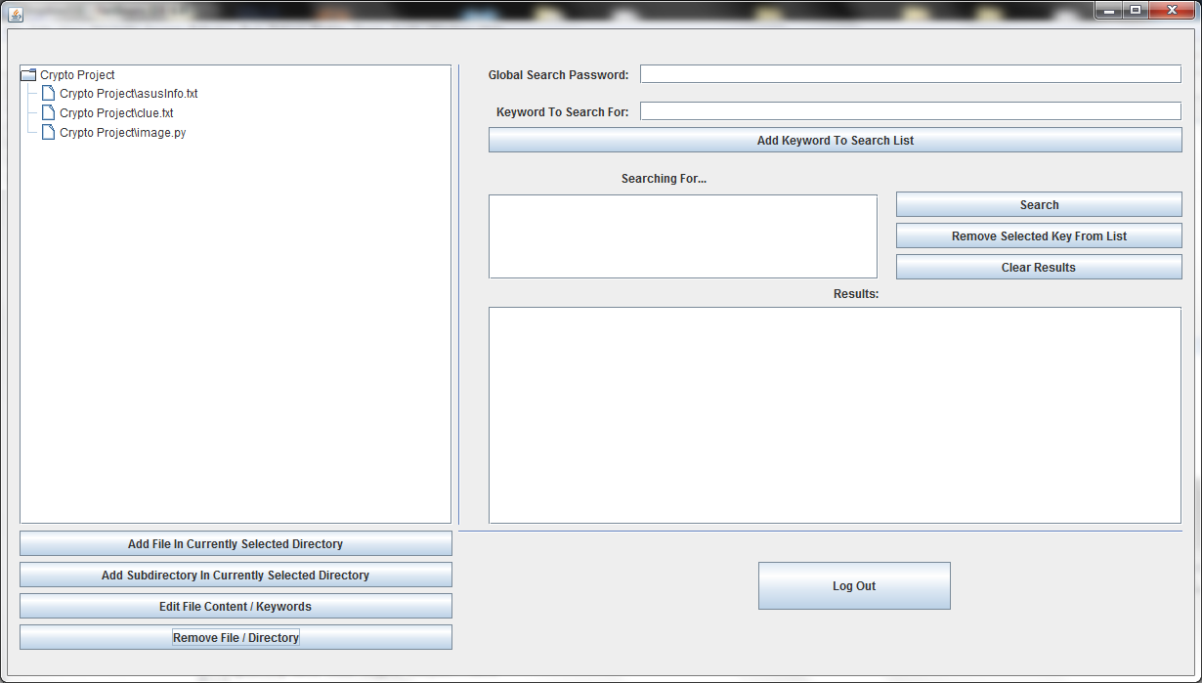

Explanation of Buttons:

- Add File in Currently Selected Directory: Add an encrypted file to the currently selected folder (root if no folder is selected). You will be asked for the file's encryption password and its search password.
- Add Subdirectory in Currently Selected Directory: Create a subdirectory in the current directory (root if no folder is selected).
- Edit File Content/Keywords: Opens the selected file in the Edit Window, which is detailed below.
- Remove File/Directory: Removes the currently selected file or folder
- Add Keyword To Search List: add the keyword typed in the above field to the list of keywords to search for
- Search: search for the list of keywords in the "Searching For..." list box. You must supply the search password in the "Global Search Password" field in order to use the search function
- Remove Selected Key From List: remove the selected key from the "Searching For..." list box
- Clear Results: clear the "Results:" list box
- Log Out: delete the user's dropbox credentials from the machines and close the application

The Edit Window

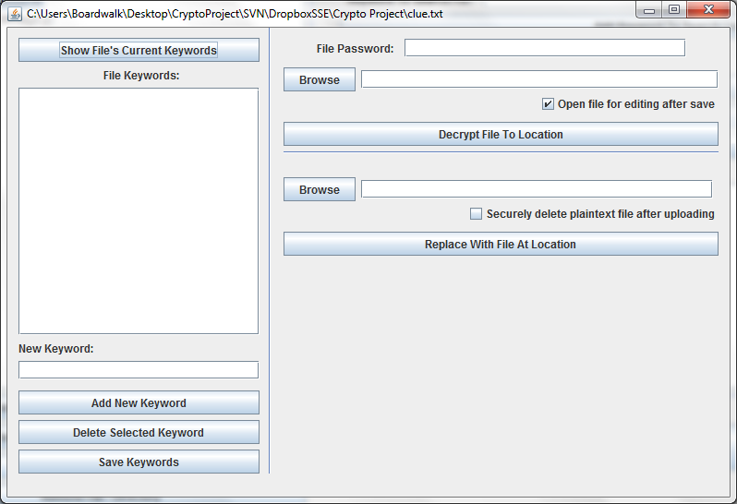
Explanation of Buttons:

- Show File's Current Keywords: reveal the file's keywords. You must give the correct password (the file's search password). You must do this before being able to use the add, delete, or save keyword buttons.
- Add New Keyword: adds a new keyword to the list of keywords. This action must be followed by the Save Keywords action before any permanent changes are made.
- Delete Selected Keyword: delete the selected keyword from the list of keywords. This action must be followed by the Save Keywords action before any permanent changes are made.
- Save Keywords: save the currently shown list of keywords.
- Browse (upper): Choose a file path to decrypt this file to
- Decrypt File To Location: Decrypt this file to the chosen location. You must give the correct password (file password)
- Browse (lower): Choose a file path to replace this file with
- Replace With File At Location: replace this file with an encrypted version of the file at the given location. This will not remove the file's keywords, only change its content.

